

**The Bioenergy Project**

Trip Report

Winter 2014, Tanzania

*Anna Miller*

*Samantha Weaver*

*Frank Zhang*

*Peter Lobel*

# Table of Contents

Table of Contents

Abstract

Project History

Initial Conditions

Impact Analysis General Results

Winter 2014 Work

Summary

Calendar

Group Meetings

Dr. Rajabu

EMORG

Vision for Youth

Lulu Vicoba

Dr. Njau

Upendo

Group Connection Meetings

Vision for Youth and EMORG

Vision for Youth and Lulu VICOBA

EMORG and Lulu VICOBA

Product Development

Grinder

Top Lit Updraft Kiln

Economic Analysis Summary

Financial Report

Future Recommendations

Unresolved Issues

Additional unresolved issues by group:

Suggestions for Wrapping-up Work in Arusha

Suggestions for Future Bioenergy Trips

Appendices

Appendix A: Most Significant Change Stories

Appendix B: Checklist for Successful Briquetting Operations

# Abstract

The 14W Tanzania travel team with DHE’s Bioenergy group is the second to last team working on briquetting in the Arusha (and Kigoma) region. The bioenergy project aims to address deforestation and health issues as a product of cook fuels. As the penultimate team, we conducted a lot of impact analysis in order to see what DHE has accomplished in Tanzania as well as wrapping up with groups in the form of connecting them with each other and ensuring that they are all in a competent place. This report serves to provide the reader with an update of all progress made up to this point, as well as to address what future steps need to be taken. We will present updates on partners, new technology/tools, financial reports, and finally make suggestions for the final Tanzania travel team (14X).

# Project History

What would eventually inspire the foundation of the Bioenergy Project started with an assessment trip to the Kigoma region of western Tanzania in 2008. The original impetus was to address issues related to deforestation, flooding, erosion, and water contamination. From this first trip, the group identified two primary issues: inefficient cookstoves, and inadequate access to latrines and information about sanitation. Afterwards, students began collaboratin*g* with Dr. Rajabu, an Engineering Professor at the University of Dar es Salaam, and Mr. Mtiti, the Director of the Jane Goodall Institute, to develop technical solutions to these issues.

From 2008 to 2011, DHE’s efforts in Tanzania primarily focused on designing and fielding improved cookstoves. During this time, DHE trained villages in the Kigoma region how to build and use the rocket stove with the help of the Jane Goodall Institute. In the fall of 2011, students developed a stove to burn coffee husk as part of an engineering design capstone project. This later evolved into the loose biomass stove, which can burn a number of fuels including sawdust, coffee husk, rice husk, and other agricultural waste materials. Simultaneously, DHE also spent significant effort exploring water sanitation and wind power projects. DHE analyzed the water quality of villages in the Kigoma region, installed pit latrines, and disseminated information about solar water disinfection (SODIS) technology. In addition, DHE installed a wind anemometer to collect wind velocity data for a potential wind turbine. Although these projects were never implemented for a variety of reasons, through these experiences, DHE learned the importance of community involvement and support for its projects.

As another side project, biomass briquetting was first explored during the summer of 2011 in response to a shift in objectives to addressing problems revolving around household health and energy security. Following a change in the base of operations from the Kigoma region in western Tanzania to the Arusha region in northern Tanzania in 2012, briquetting began to take a more prominent position among DHE’s repertoire of mature technologies. During the spring and summer of 2012, DHE travelers established NGO partners in the Arusha region, conducted a briquetting training program, and continued to develop and receive feedback on the loose biomass stove*.*

It was between the summer of 2012 and 2013 that the Bioenergy Project really came into its own. At the same time, work on-campus began to focus on better understanding the chemical preprocessing (i.e. carbonization) of wood and agriculture-based biomass using theory developed from working with the loose biomass stove. This would pave the way for charcoal briquetting to become a primary focus of the Bioenergy Project. Work over the summer of 2013 began development of the BLSD carbonizer to convert loose biomass into charcoal using cheap, locally available materials, while continuing to build on the briquette training program initiated the previous summer in Arusha. By this time, efforts abroad have finally matured to focus on community capacity building, which revolves around sharing knowledge and skills as opposed to simply importing mature technologies overseas with little accompanying education.

With the imminent expiration of the initial grant from Green Mountain Coffee Roasters (GMCR) in the summer of 2014, the current team is tentatively the penultimate group to travel to Tanzania. Building upon the work already conducted in the Arusha region, the major focus of this trip was conducting impact analysis in order to gauge the effectiveness of DHE’s project work in regards to charcoal briquetting to inform future work in other contexts. In addition, the other primary objective was ensuring that each of the groups that DHE has worked with in the past were suitably prepared to continue production in our absence through additional capacity building as necessary.

# Initial Conditions

## Impact Analysis General Results

On the 14W trip, we conducted a significant amount of impact analysis that specifically looked at the 13X team’s work and where our partners stand as of now. We have collected data on our partners’ efficiency in the briquetting process, the financial feasibility of the operation and “Most Significant Change” (MSC) stories which aim to see the impact of Dartmouth Humanitarian Engineering in the Arusha region through narrative.

Out of our four partners, only one is currently carbonizing. Vision 4 Youth (V4Y) has a kiln in their workspace and it is their sole source of charcoal for the briquettes. The kiln, however, does not yield a great product. That said, they understand the process of carbonization and would benefit greatly from a better kiln design. Also, although they are using the kiln to make their own charcoal, it is still not from “waste.” They are using sawdust that would otherwise be used for some other purposes (animal bedding, etc). They understand the importance of making briquettes from waste, but do not know how to get access to other forms of biomass that do not already have a purpose. V4Y currently has seven unpaid workers who are running the operation and making about 56 briquettes per session (usually there is one pressing session per week). They are currently looking to expand their operation so that they can profitably sell their briquettes (projected price is 600 tsh per kilogram of briquettes). In their MSC story, V4Y spoke of how DHE helped them begin their production by sharing ideas and tools. “We are starting to see that our dream is almost coming true because we have the kiln and production is going well,” said Violet Ayoub (leader of V4Y). They are currently raising money to expand their operation by buying a larger plot of land and getting machines to help with their production. They have about $2,000 now as well as someone in Moshi who is interested and willing to invest in their briquettes.

Another one of our partners, the women’s group at Educational Model Organization (EMORG), has made great progress since starting to work with DHE. Although, they are not carbonizing regularly, their process has become very efficient and potentially profitable. They have a Bottom-Lit Side Draft (BLSD) kiln that the 13X team provided for them, but they are not using it because the charcoal it yields does not burn as well (according to the women’s group). They are collecting charcoal fines after the market day, which has provided them with more than enough material. They often have a bucket of charcoal leftover after they have pressed as many briquettes as they can in a day. They currently have 12 members who are not paid for their work and the group as a whole is 200,000 tsh in debt to EMORG. They have been selling some, but very few, briquettes at the price of 1,000 tsh per kilogram. The money that they earn from these sales goes towards paying back their debt at EMORG. Their only expense at the moment is for cassava. We will discuss this later in the economic analysis, but we have found that with these numbers, their operation can be profitable. Since their briquetting operation has not been generating income yet, one of their greatest needs has been in capital costs. With this, their MSC story had a lot to do with their appreciation of the 13X team providing them with the presses and molds that they needed for their operation.

Lulu VICOBA, DHE’s oldest partner, is the only group that was successfully selling briquettes before the arrival of the 14W team. They sell mostly among themselves, but they will also sell to outsiders. They are also one of the groups (out of only two) that creates doughnut briquettes and uses newspaper binder. They are currently making about 100 briquettes per week and selling everything that they are able to make. They are selling their briquettes at 300 tsh per briquette, which makes them the only group that is selling by piece and not by mass. There are 30 women in the Lulu VICOBA group and they all participate in briquetting operations.

# Winter 2014 Work

## Summary

While impact analysis was the primary focus of work in the 14W trip, the team also worked to establish a support network between the partners and introduce new technology. During the trip, the team was able to meet with Dr. Rajabu, Dr. Njau, Bernard of AISE, Vision for Youth, EMORG, Upendo, and Lulu Vicoba. Connection meetings occurred between Vision for Youth, EMORG, and Lulu Vicoba, but Upendo was unable to attend joint meetings. Finally, the 14W team explored options to improve the charcoal processing step. Methods currently used to break charcoal into smaller pieces are slow, messy, and laborious. The 14W team looked into the creation of a charcoal grinder in order to improve efficiency and health during this step.

## 

## Calendar

|  |  |  |  |  |  |
| --- | --- | --- | --- | --- | --- |
| Monday | Tuesday | Wednesday | Thursday | Friday | Saturday |
| 3  - Initial V4Y Meeting | 4  - V4Y Burn | 5  - Met with Dartmouth Intern  -Met Dr. Rajabu | 6  - Initial EMORG Meeting | 7  - V4Y Pressing  - Painted EMORG | 8  - Upendo Initial Meeting  - Campus Call |
| 10  - Advisor Call | 11  - V4Y Meeting | 12  - EMORG market  - Met with Bernard | 13  - EMORG | 14 | 15  - Campus Call |
| 17  - Advisor Call | 18  - Grinder w/Bernard | 19  - EARD-CI meeting  - Grinder w/Bernard | 20  - EMORG  - V4Y | 21  - V4Y/EMORG Meeting | 22  - EMORG  - Campus Call |
| 24  - Lulu Vicoba  - Advisor Call | 25  - TLUD fabrication | 26  - EMORG Market | 27  - TLUD fabrication | 28 | 1  - EMORG  - Campus Call |
| 3  - Advisor Call  -Lulu Vicoba/V4Y | 4  - Met Dr. Njau  - Upendo | 5  - EMORG Market | 6 | 7  - V4Y/Upendo | 8  -EMORG/Lulu Vicoba |

## Group Meetings

### Dr. Rajabu

The 14W team met with Dr Rajabu at the University of Dar es Salaam during the first week of the trip. At this meeting, we also met Christian Riu Lohri from the Swiss Federal Institute for Aquatic Science and Technology in Switzerland and two graduate students working with Dr Rajabu at the College of Engineering and Technology at University of Dar es Salaam. They have been working intensively on a joint research project focusing on the carbonization of urban biowaste in Dar es Salaam, and they filled us in on much of their work. Specifically, the masters students presented on a couple developing prototypes they are working: a solar biomass dryer and an improved rotating-barrel carbonizer. Since these are both developing prototypes, they are something to keep an eye on and worth considering, but they are not immediately relevant to our work in Arusha.

After meeting at the University, we paid visits with Dr Rajabu and Riu to Sustainable Energy and Development Centre (SEDC) and the Dar es Salaam branch of Appropriate Rural Technology Institute (ARTI). At each of these visits, we learned about large-scale charcoal briquette production. At SEDC we saw large-scale carbonizers, pressers, and green-house type dryers for charcoal briquettes and collected information about them. At ARTI, we met with the Executive Director, Nachiket Potnis, and learned about their process in spreading and initiating charcoal briquetting in the Dar es Salaam region. Both of these visits were especially helpful in our efforts to collect data in order to run effective economic and mass/energy analyses.

### EMORG

*Initial:*

The 14W team met with EMORG’s women’s group ten times. The first meetings focused on operation evaluation, impact analysis, and discovering aspects of the process that most needed improvement. The group was very interested in improving carbonization and grinding steps of their briquetting process, and in starting to sell briquettes.

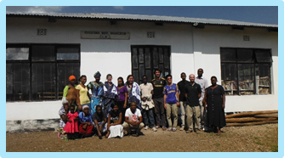

*The 14W team with the EMORG women’s group*

Observing how slow and laborious the grinding process at EMORG was inspired the creation of the grinder prototype, with the help of Bernard at AISE.

*Markets:*

DHE attended the Kisongo market three times with the women’s group. It was the first time that they had attended the market. They paid 500 TSH for space at the market each time they went. A major inhibition to selling was the lack of a scale. The women’s group wanted to sell briquettes by mass, instead of by piece, because the briquettes are unevenly sized. After attending market twice with the women’s group using the DHE scale, the 14W team deemed it appropriate to contribute funds to purchase a permanent scale.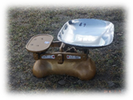

|  |  |  |  |  |
| --- | --- | --- | --- | --- |
| Trial | Time Spent at Market | Kgs of Briquettes Sold | Total TSH | # Buyers |
| 1 | 30 minutes | 4 | 4,000 | 2 |
| 2 | 90 minutes | 6 | 6,000 | 4 |
| 3 | 70 minutes | 11 | 10,000 | 2 |

The first time at the market, the women had to leave early due to rain, while the second and third times they needed to leave to attend to their families. Despite the short time intervals spent, it was encouraging to see that the briquettes were being sold. The women set up next to the lump charcoal sellers, displaying the briquettes on the scale and moving around the immediate vicinity to market the briquettes.

*Final State:*

At the time that the 14W team departed, the women’s group was working on developing a new grinder. The 14W team gave the grinder prototype to EMORG as a model for the larger machine. The hired carpenter promised to have the machine complete before the 14W team departed. The machine presented by the carpenter was substandard and incomplete. The 14W team described how to improve the larger machine to the carpenter, the women’s group, and the EMORG project manager. The project manager has promised to email pictures of the finished product to DHE, along with regular updates on the women’s group progress in using the grinder.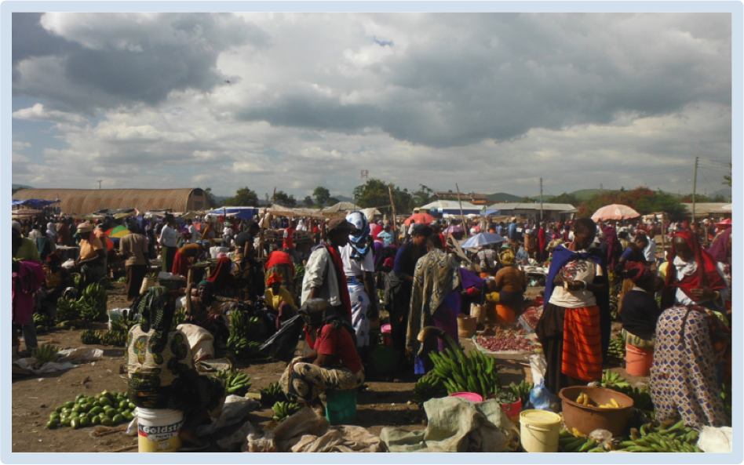

During 14W the women’s group began going to market on Wednesdays (see the picture to the right). This is the first time that they have sold briquettes on a regular basis. The scale financed by DHE has allowed the group to regularly sell briquettes, and, as of this writing, the women’s group plans to continue to attend market. The project manager at EMORG has promised to send updates on how selling is going.

Before 14W the women’s group had started a side project of creating beaded bracelets and sandals to sell. The project manager indicated that before the 14W team arrived, interest in briquetting was waning and the group focused on beading. Interest in briquetting was rekindled during 14W, but it still seems very likely that the group may return to focusing on beading, as it is less labor intensive and more profitable than briquetting.

### Vision for Youth

*Initial:*

DHE met with V4Y seven times. During initial meetings, V4Y conveyed that they were most interested in expanding their operation. Their biggest identified challenge was obtaining funds for expansion and equipment. V4Y was identified as a potential link between partners (someone to introduce all the other partners to each other in order to establish a briquetting support network in Arusha). It was a priority to bring V4Y to meet other partners during 14W, although new equipment was explained and introduced as well.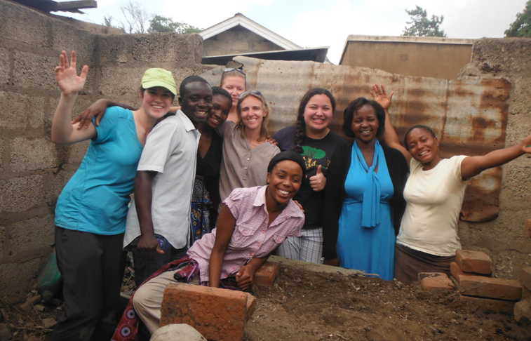

*Group Meetings:*

Vision for Youth put the most effort into trying to connect with the other groups. They visited two other groups, and attempted to visit the third. Numbers were exchanged at each of the meetings, and partners seemed very interested in continuing communication (though it is unclear if this will become a reality). For more details on the group meetings, please see the Group Connection Meeting section below.

*Final State:*

Vision for Youth was working hard on fundraisers to purchase land for their briquetting operation. They were connected with Lulu Vicoba and EMORG, and have traveled to teach another group how to briquette. They do not want to begin selling briquettes until they are able to produce enough to support their consumer base. They are at a standstill in briquetting improvement, though we hope collaboration with the other partners will provide new ideas and resources. Interestingly, they are the only group carbonizing waste, though their kiln does not function very well.

### Lulu Vicoba

A communication problem delayed the initial meeting with Lulu Vicoba until late in the trip. There was one casual meeting with Edith of EARD-CI, a meeting with Naomi at EARD-CI, and two meetings with the Lulu Vicoba group. They were the only group working with newspaper as a binder, and were interested in meeting with the other partners. They were most interested in beginning to carbonize waste, as currently they are briquetting with purchased and scavenged charcoal at markets (which are not located in the village). The group was connected with EMORG and V4Y in order to examine bottom lit side draft kilns and share their experiences selling briquettes.

### Dr. Njau

Near the end of the trip the team had an opportunity to meet with Professor Karoli Njau, a dean at the Nelson Mandela African Institution of Science and Technology. Professor Njau specializes in sustainable waste streams, and though he is currently focused on waste water treatment, has worked on briquetting in the past. Because we found that most agricultural waste in the Arusha region was being fed to farm animals, we asked Prof. Njau specifically on viable waste streams for briquetting in the Arusha region. He recommended:

Rice Husks—contain silicates, and are fed to animals less frequently

Coffee Husks—same benefits as rice husks

Sawdust—can become a problem around sawmills

Market Waste—this includes the grass baskets used to contain some goods.

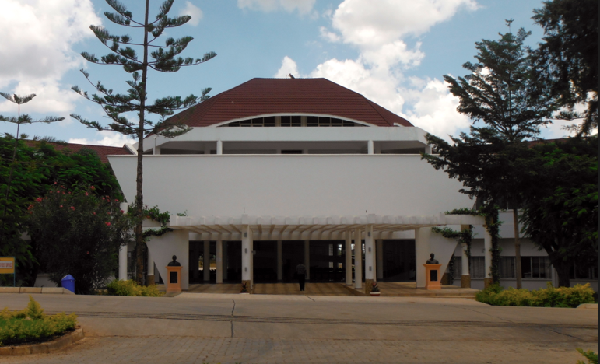

*Mandela Institution of Science and Technology*

### Upendo

We were able to meet with the Upendo group twice. The first time, we met with Julius Sossy and his wife, and, the second time, we had the opportunity to observe the briquetting process. The Upendo group faces many challenges, including a lack of time (which is needed for other jobs to provide for families) and access to carbonized material. While the woman who pressed a briquette for us seemed to understand the process well, she only made a single briquette (for our benefit) which did not have enough material, cracked, and quickly fell apart. Upendo was interested in learning from our other partners, and beginning to carbonize waste for briquettes. The 14W team explained the function of a TLUD to them, and set up a meeting with Vision for Youth with Upendo. Unfortunately Upendo was unable to attend this meeting. 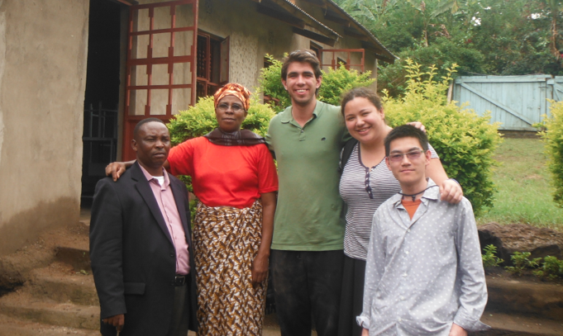

## 

## Group Connection Meetings

### Vision for Youth and EMORG

Miss Ayoub and Violet from Vision for Youth met with two members of the EMORG women’s group outside of Shoprite. Miss Ayoub translated for the 14W team. Vision for Youth was interested in how the women’s group was selling briquettes at the market, and interested in seeing how the briquetting operation functioned. Numbers were exchanged at the end of the meeting.

### 

### Vision for Youth and Lulu VICOBA

Miss Ayoub and Violet travelled to Lulu VICOBA’s workspace with the 14W team. They were interested to discover that the Lulu VICOBA group was using newspaper in their briquettes, which V4Y has not previously done. Numbers were exchanged at the end of the meeting.

### EMORG and Lulu VICOBA

Two representatives from Lulu VICOBA travelled to EMORG to observe charcoal processing, the creation of the cassava porridge, and briquette pressing. They spoke with each other about selling briquettes, newspaper binder, and cassava binder. Both groups make cultural items (beaded bracelets, etc.) in addition to briquetting, so the creation and sale of these items were also major topics of discussion.

### 

## Product Development

### Grinder

The 14W travel designed a prototype of a charcoal grinder to be used by our partners in Arusha. This project was undertaken as a response to a very clear need in the charcoal grinding step of the charcoal briquetting process. After our initial visits to the partners, we realized that the current methods used to grind charcoal were not only unhealthy but also a fairly limiting step in the process time-wise. The methods being used were crushing it with a mortar and pestle, breaking i into fine pieces by hand, or whacking it to pieces in a sack with a stick.

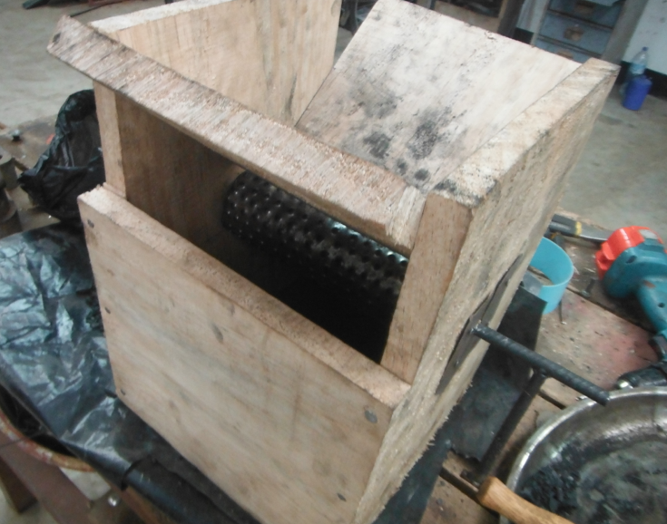

With help from Bernard and a couple workers at his workshop, we designed a prototype that uses circular motion to crush the charcoal. This grinder prototype is made from a wood base, sheet metal with holes punctured by a nail, and a metal cylinder attached to a handle for easy rotating. We also added a plunger (just a T-bone of wood) and a chicken-wire sifter at the bottom to add to operator friendliness. For operation, charcoal lumps are inserted into the top while the wheel is cranked by hand at the side. As it goes down, the charcoal is caught and shredded by the metal teeth against a metal edge on the bottom side of the angled piece of wood. Added pressure from the plunger helps add the necessary pressure needed for the charcoal to be grinded.

This prototype is not a finished product. While it does grind the charcoal into smaller pieces, it does not grind it into fine enough charcoal dust yet to be used properly in charcoal briquettes. We didn’t have the time to implement this, but one idea for improvement is to add teeth to the metal edge and have them offset from the teeth on the wheel; this way there is less room for bigger pieces to sneak through the grinding wheel.

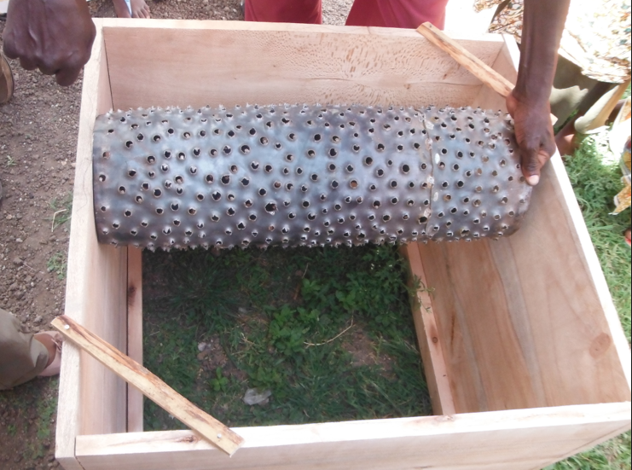

We shared the grinder prototype with two of our partners, EMORG and Vision for Youth. Both groups showed excitement and willingness to work with local carpenters to implement and improve upon the current design. We provided them with some funds to accomplish this.

### Top Lit Updraft Kiln

A model Top Lit Updraft kiln was created with the help of workers in Bernard’s workshop. The kiln was made by modifying a loose biomass stove left behind by the 2012 trips. It consists of five separate parts: legs, body, after-burner, chimney, and lid (for stopping the reaction). 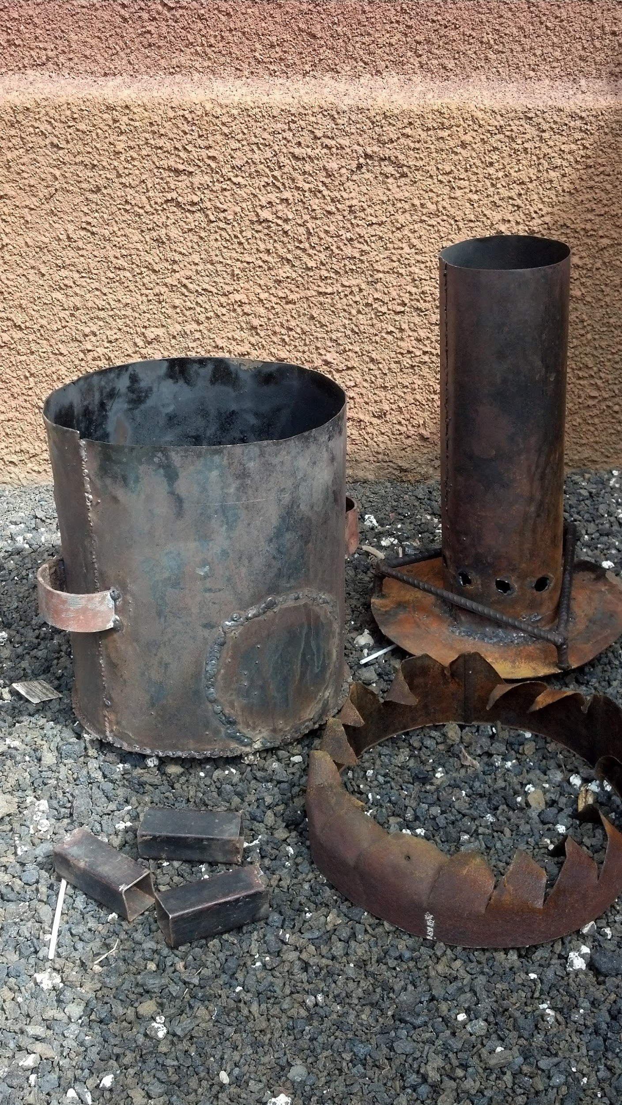

Initial burns were very fast, hot, and smoky (Figure 1). The team hypothesized that there was excessive primary air, and a secondary air deficiency. Mud and a grate were used to block some of the primary air holes, while the after-burner was modified to have larger slits (Figure 2).

Blocking the holes with mud, instead of a more permanent method, allowed the 14W team to experiment with different air-flows, but also resulted in a fairly temperamental kiln. To limit this variability in future demonstration models, wide headed nails or screws should be used to change the amount of primary air available.

The TLUD functioned well with sawdust, but poorly with sticks and irregular biomass. The 14W team believes this is due to the irregular nature of the sticks; it is harder to find the appropriate time to end the reaction, before the twigs ash but after the main sticks have surpassed torrefaction. A better kiln design or biomass pre-processing may be necessary to remedy this, if the kiln is to be used with irregular biomass.

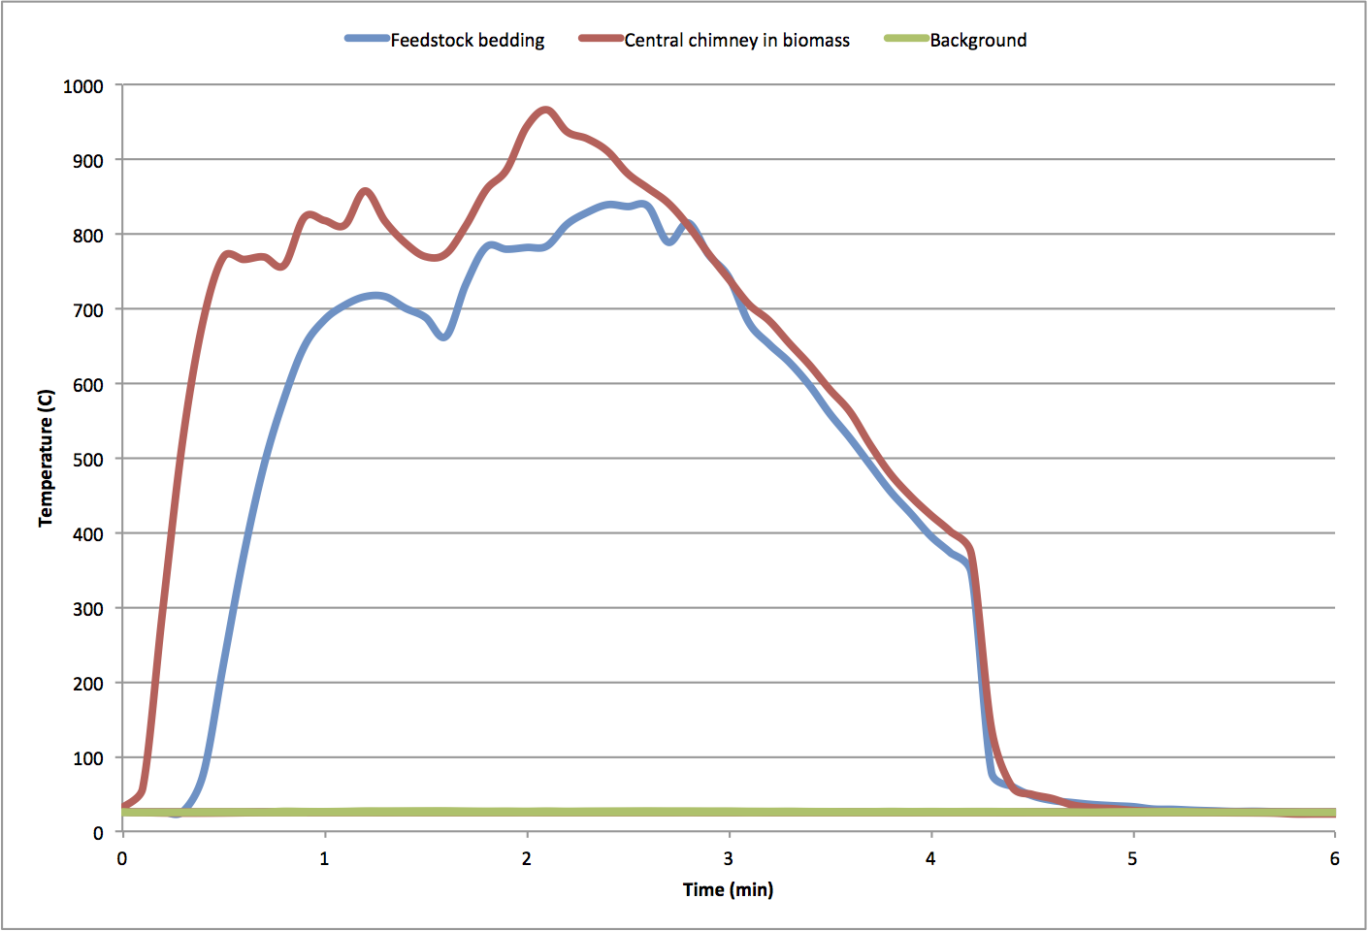

Figure 1

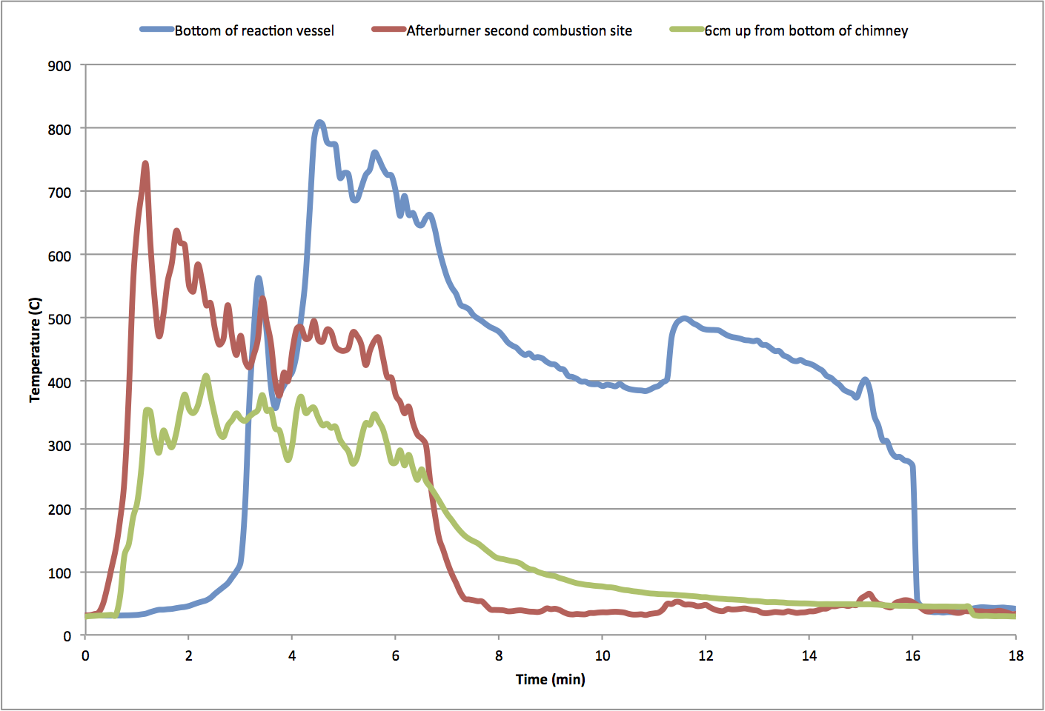

Figure 2

# Economic Analysis Summary

From the start of its time in Arusha, DHE has supported local entrepreneurs interested in producing alternative cooking fuel through capacity building revolving around the production of fuel briquettes. Since DHE is limited to being in-country for a short period of time, the project relies on its partnerships with producer groups and their commitment to continue production in our absence to have a sustainable impact. Consequently, the intention with each producer group is to enable the participants to start their own small businesses selling the briquettes that they produce, thereby providing an incentive to utilize new knowledge. However, unless these small businesses can earn a positive profit ex post, financial constraints will likely prevent them from either expanding or continuing to operate for long after the project comes to a close. To that end, the Winter 2014 trip spent a significant amount of time assessing the profitability of a briquetting operation in Arusha.

The current analysis focuses on gathering sufficient information on operating costs and subtracting them from total revenue to determine operating profit. For a small-scale operation, costs are incurred through the purchase of raw materials and recouped through product sales. Materials fall under two basic categories: filler, and binder. A briquette mixture must include fibrous binders (DHE has traditionally used cassava porridge, and paper pulp) and pre-processed fillers (i.e. carbonized sawdust or wood charcoal fragments) in order to hold properly after pressing while still providing a clean, hot burn. Since an optimal mixture typically combines these two materials in near fixed proportions, current work has attempted to backtrack the cost of production using the recipe ratios and price of materials as parameters.

Much of the framework discussed here was developed on campus prior to departure using data collected from the previous travel team, including carbonization yield (from kiln operation), cost information, and recipe proportions. These values were then either confirmed or updated upon travel to Tanzania. Table 1 provides costs on a kilogram basis in addition to their source and method of derivation. An issue faced by previous travel teams was that many of the purchases were made in-person, hence raising the issue as to whether they were overcharged (as many foreigners to the country are). Consequently, to avoid this problem, we asked the groups directly about the types of materials being used to produce briquettes and their associated prices, thereby acquiring a more accurate sense of the operating costs being faced by each of the groups.

|  |  |  |  |  |
| --- | --- | --- | --- | --- |
| **Material** | **Cost (tsh/kg)** | **Method of Acquisition** | **Location** | **Source** |
| Sawdust | 260 | 2,000 tsh for ~7.6 kg | Njiro | 14W Purchase (Price confirmed with Bernard) |
| Charcoal Fine (scavenged) | 0 | Collected after market days | Kisongo | EMORG |
| Charcoal Fine (purchased) | 1,470 | 15,000 tsh for 1 bag* | Tengeru | Lulu VICOBA |
| Cassava Flour | 4,000 | 4,000 tsh for 1 kg | Kisongo | EMORG |
| Wheat Flour | 1,400 | 700 tsh for 0.5 kg | Esso | V4Y |
| Paper Waste | 0 | Recycled from friends | Ubiquitous | Lulu VICOBA |
| Water | 0 | - | Ubiquitous | - |

*Table 1 - Cost Information*:

*\*When asked in an interview, Lulu Vicoba reports purchasing 1 bag of unknown mass of charcoal for 15,000 tsh per session. They also report being able to make 100 briquettes in a single session. Assuming that each briquette produced is a “donut” briquette with an average mass of 0.18 kg, we determined the amount of charcoal necessary to produce 100 such briquettes and equated the quantity to the amount of charcoal originally in the bag.*

Table 2, on the other hand, lists the requisite amounts of each material needed to produce a kilogram worth of dry briquettes on a group-by-group basis. Note that since the final moisture content of the briquettes is assumed to be negligible, any added water during fiber processing does not contribute mass to the final product. Yield of carbonization was also assumed to be 25% of initial input mass. Recipes were determined through visits to each group’s production site to observe the briquetting process performed by the participants. Throughout the session, the mass of the inputs were measured with a digital scale by the travellers as they were being mixed into slurry. Total operating cost on a kilogram basis are determined by summing the cost over all raw materials and then accounting for any extraneous costs such as marketing and transportation. These latter costs are relevant in particular to EMORG’s women group and Lulu Vicoba respectively. Specifically, the former must pay 500 tsh each week to secure a spot at the local market through which they can typically sell 7 kg of briquettes, whereas the latter must pay 5,000 tsh to transport each bag of charcoal (enough to produce around 20 kg of briquettes by our calculations).

|  |  |  |  |  |  |  |  |
| --- | --- | --- | --- | --- | --- | --- | --- |
|  |  | **EMORG** | **Cell** | **VICOBA** | **Cell** | **V4Y** | **Cell** |
| **Material** | **Cost (tsh/kg)** | *Quantity (kg)* | *Total Cost (tsh)* | *Quantity (kg)* | *Total Cost (tsh)* | *Quantity (kg)* | *Total Cost (tsh)* |
| Sawdust | 260 | - | 0 | - | 0 | 3.592 | +934 |
| Charcoal Fine (scavenged) | 0 | 0.898 | 0 | - | 0 | - | 0 |
| Charcoal Fine (purchased) | 1,470 | - | 0 | 0.794 | +1,167 | - | 0 |
| Cassava Flour | 4,000 | 0.102 | +408 | - | 0 | - | 0 |
| Wheat Flour | 1,400 | - | 0 | - | 0 | 0.102 | +143 |
| Paper Waste | 0 | - | 0 | 0.206 | 0 | - | 0 |
| Water | 0 | 0.798 | 0 | 1.427 | 0 | 0.798 | 0 |
|  |  |  |  |  |  |  |  |
|  |  | **Subtotal (tsh)** | 408 | **Subtotal (tsh)** | 1,167 | **Subtotal (tsh)** | 1,077 |
|  |  | Renting Market Space | +70 | Renting Market Space | +0 | Renting Market Space | +0 |
|  |  | Transporting of Materials | +0 | Transporting of Materials | +250 | Transporting of Materials | +0 |
|  |  |  |  |  |  |  |  |
|  |  | **Average Cost (tsh/kg)** | 478 | **Average Cost (tsh/kg)** | 1,417 | **Average Cost (tsh/kg)** | 1,077 |

*Table 2 - Derivation of Average Cost: EMORG and Vision for Youth produce starch binder briquettes using cassava, whereas Lulu Vicoba produces cellulose binder briquettes using paper. In either case, the ratios of each material are adjusted so the mass of organic material (i.e. charcoal, flour, paper) equals one. For sawdust, the equivalent amount of charcoal is multiplied by four (assuming 25% yield) to determine the starting amount of feedstock necessary to produce the requisite amount of char.* Costs for renting and transportation are determined by dividing the total cost of the service by the amount of dry briquettes that can be made/sold through acquisition of the service.

Compared to cost estimates (average cost: 310 tsh/kg for a hypothetical operation performing carbonization and using cassava porridge) derived on-campus, the average costs determined abroad are higher across the board for each of the groups, contrary to expectations. Positive deviations mostly reflect the higher than assumed cost of materials (original assumptions were P sawdust = 78 tsh/kg and P cassava = 300 tsh/kg).

Based on these findings, the most viable method of production with the least cost is the one currently being pursued by the women’s group at EMORG, which involves collecting charcoal fines for free at major marketplaces and mixing it with cassava flour. However, upon first inspection, further cost savings could be gained by switching to wheat flour or paper (though prices may vary across markets). Free charcoal fragments notwithstanding, the cost of filler accounts for most of the average cost (upward of 80%), hence emphasizing the importance of access to low-cost waste streams to the success of a briquetting operation. Currently, the process of carbonizing sawdust is only marginally cheaper than purchasing charcoal fines, with savings around 230 tsh per kilogram of dry briquettes produced. Therefore, considerations regarding the viability of carbonization should be tied closely to the cost of raw feedstock.

Pricing schemes are detailed along with expected profit per kilogram in Table 3.

|  |  |  |  |
| --- | --- | --- | --- |
| **Group** | **Price (tsh/kg)** | **Cost (tsh/kg)** | **Profit (tsh/kg)** |
| EMORG | 1,000 | 478 | 522 |
| Lulu Vicoba | 1,667* | 1,417 | 283 |
| V4Y | 600 | 1,077 | -477 |

*Table 3 - Pricing Scheme and Profit*:

*Lulu Vicoba is the only group who intends to sell by piece as opposed to mass. Their current scheme is 300 tsh per briquette, which assuming an average mass of 0.18 kg per briquette is approximately 1667 tsh per kilogram.

Based on the figures in Table 3, the EMORG operation is currently posed to earn positive profit moving forward. Based on weekly production and sales of approximately 7 kg, this translates to 3,600 tsh per week (4+ hours of work) for a group of seven people, or a little over 500 tsh per capita.

The Lulu Vicoba group, though still earning positive profit, charges the most per kilogram and has the largest workforce to support, with at least 30 women consistently attending sessions. They also spend the least amount of time pursuing briquetting activities, little more than two hours per week following community banking meetings. Further productivity data is lacking for this group however, so future growth prospects are uncertain.

Concerning Vision for Youth, current analysis suggests that their target price is too low to support their current operating costs. Still, out of all the groups, their target price is the most realistic, so future improvements should focus on addressing costs. Unfortunately, if prices in Njiro are any indication, the cost of sawdust is prohibitive for their use as feedstock for carbonization. Furthermore, the current state of the BLSD kiln, requiring 24+ hours to produce less than four kilograms of charcoal, puts a serious constraint on productivity. Though carbonization still has its environmental and possibly economic benefits, further work must be conducted to ensure the benefits are attainable.

# Financial Report

For the Winter 2014 trip, expenses from the GMCR grant totaled $5,446 (this excludes international travel). These expenses were split into four categories: domestic transportation, equipment, room & board, and other miscellaneous expenses as detailed in the chart below. Miscellaneous expenses include costs such as translators, visas, and bank fees. Room & board are included together as one category because most of it was included together as part of the housing arrangement.

International travel expenses, funded by the Dean’s Fund, totaled approximately $8,000. Each of the travelers contributed $500 towards this, resulting in $6,000 coming from the Dean’s Fund. *Need to look up exact numbers for international plane tickets.

|  |  |  |
| --- | --- | --- |
| Expense Category | Projected Budget | Actual Expense |
| Room & Board | $2500 | $2,580 |
| Domestic Transportation | $1700 | $1,276 |
| Equipment | $1000 | $414 |
| Miscellaneous | $1050 | $1084.48 |
|  |  |  |
| **Total** | **$6250** | **$5,446** |

# Future Recommendations

## Unresolved Issues

There are three main challenges left to overcome in work with partners in Arusha: waste stream connection, kiln functionality, and sales confidence.

*Waste Streams*: The anticipated waste for carbonization, agricultural by-products, are being used to feed animals and return nutrients to the soil. Partners have been using wood based materials, like sawdust (which is also used in animal pens and must be purchased) and lump charcoal fines. To optimize the financial and environmental benefits of briquetting, partners should be connected with proximal waste streams.

*Kiln Functionality*: Bottom lit side draft kilns currently being used by partners are temperamental. They produce a lot of smoke in the initial combustion phase, and result in a lot of ash and un-carbonized material. Developing a full scale, functional kiln needs to be emphasized.

*Sales Confidence*: While all of the groups wish to sell their briquettes, only two of them (V4Y and Lulu Vicoba) have made attempts to do so. Partners who have not begun to sell should be introduced to markets, or encouraged to begin selling among their acquaintances. Partners who are attempting to sell should be encouraged to continue, without DHE present, and to explore different consumer options.

## Additional unresolved issues by group:

|  |  |
| --- | --- |
| Vision for Youth | 1. Space (not someone’s backyard) 2. Improve the grinding process 3. Begin selling |
| EMORG | 1. Improve the grinding process 2. Establish a space for drying 3. Encourage briquette sales |
| Lulu Vicoba | 1. Desires a kiln 2. Observe how they sell outside the group 3. Increase time spent briquetting |
| Upendo | 1. Begin selling 2. Experiment with carbonization 3. Observe the complete briquetting process with all members present |

## Suggestions for Wrapping-up Work in Arusha

*1. Connect partners to waste streams*

Of the challenges listed above, the most important one connecting the partners to viable waste streams. Dr. Njau and Didas have mentioned rice plantations and sawmills near Usa River (the same region as the Lulu Vicoba group). Access to this waste would increase the environmental impact of the operations and reduce constant costs. Locating the waste, or encouraging partners to seek it out on their own, is something that the 14X team could accomplish in their limited time in Arusha.

*2. Monitor Connections*

The 14X team should determine what (if any) benefits the partners have had from being introduced to each other. If it seems like the introductions were helpful, but there has been no communication between the groups since, the 14X team should make an effort to reestablish the connections, and determine an effective method for their continuation.

## Suggestions for Future Bioenergy Trips

*Trips: Long-Term Planning*

While the Bioenergy Project has done good work in Tanzania, it faced the challenges of rapid change (from cook-stoves to biofuel). This was a necessary change based on information learned in country, and the project is now in a somewhat stable state. Knowing the intended outcome of work in country would help increase the efficiency and knowledge gained in trips.

*Campus Work: Equipment*

As an organization that focuses on briquetting capacity building, it is essential that DHE can provide designs for functional equipment. While it is important to communicate that equipment used is not the only solution (and can be improved), it is difficult for partners to improve equipment that does not exist. During 14W it was observed that the briquetting equipment used by partners was not always effective, even under the best of conditions.

Work by the campus team in the future should include the construction, evaluation and improvement of briquetting equipment. This will help build knowledge of future teams, and develop good equipment designs that can be distributed to partners.

# Appendices

## Appendix A: Most Significant Change Stories

## Story 1

**Project:** Vision 4 Youth

**Name of person recording story:** Samantha Weaver

**Role of storyteller:** Leader of the Vision 4 Youth group

**Location:** Arusha, Tanzania

**Date of recording:**

**Title of story:** “Our dream is almost coming true”

**Why was this story selected:** DHE first partnered with Vision 4 Youth during the summer of 2013. They were excited to start briquetting and had a big vision for the future, and they still do. Since the 14W team has been here, Vision 4 Youth has been working on expanding their process and making it more efficient.

**What has been the greatest impact you have noticed to your organization since you began your partnership with DHE?**

“We are starting to see that our dream is almost coming true because we have the kiln and production is going well.” They are currently raising money to expand their operation by buying a larger plot of land and getting machines to help with their production. They have about $2,000 now as well as someone in Moshi who is interested and willing to invest in their briquettes.

## Story 2

**Project:** The women’s group at EMORG

**Name of person recording story:** Samantha Weaver

**Role of storyteller:** Chairwoman of the women’s group at EMORG

**Location:** Kisongo, Tanzania

**Title of story:** “”

**Why was this story selected:** DHE has a close relationship with the founder of EMORG, Didas, and his organization has supported the women’s group in their beginning stages of briquetting. The women have used EMORG and DHE’s support very well, and have developed an efficient process and they have begun selling.

**What has been the greatest impact to your organization since you began your partnership with DHE?**

The women at EMORG spoke extensively about the 13X team and how they helped them in starting up their process. The chairwoman explained how they taught the women how to prepare charcoal and how they also gave them the tools necessary for the briquetting process (molds, presses, bottom-lit side draft (BLSD) kiln, etc). The group has borrowed money from EMORG and he also spoke about how they were excited to be selling briquettes at the market now.

## Story 3

**Project:** Lulu VICOBA briquetting operation

**Name of person recording story:** Samantha Weaver

**Role of storyteller:** Lulu VICOBA member

**Location:**

**Date of recording:**

**Title of story:** “”

**Why was this story selected:**  Lulu VICOBA is DHE’s longest current partner and is doing very well with their briquetting operation. They are the only group we have that has been selling consistently (mostly amongst themselves, but also to outsiders). We were excited to hear from them about what they have gained from briquetting.

**What has been the greatest impact to your organization since you began your partnership with DHE?**

Lulu VICOBA’s MSC story was very similar to EMORG’s. She spoke of how DHE helped them begin their briquetting organization and how in subsequent trips, DHE helped them to improve their briquetting process. They now have a fairly efficient process, although they do not work very often because of other obligations. They also shared their gratitude in DHE’s help with their equipment grants.

## Appendix B: Checklist for Successful Briquetting Operations

DHE Bioenergy should look for these qualities in new partners. They are listed in order of importance.

1. Access to a Waste Stream (agricultural residues, wood waste, charcoal finds)
   1. Free or minimal cost (No great amount of competition for the waste)
   2. Operation is close to the source of waste
2. Incentive for Briquetting (Environment, Financial, Health Purposes)
3. Desire to learn briquetting
4. Space for the operation
   1. Including shelter from the elements for drying (if applicable)
5. Money for capital investment
6. Time to learn and conduct briquetting
7. Access to briquette consumers (potentially this could include themselves)
8. Access to water
9. Access to binder